

**National University of Singapore**

**School of Computing**

**CS3201: Software Engineering Project I**

Semester 2, AY2013/2014

**STUDENTS’ PARTICULARS**

|  |  |  |  |
| --- | --- | --- | --- |
| ***Matriculation*** | ***Hp Number*** | ***Student Name*** | ***Email*** |
| A0099214B | 8518 2707 | Adinda Ayu Savitri | savitri.adinda@gmail.com |
| A0098139R | 9082 0864 | Hisyam Nursaid Indrakesuma | yohaneslim93@gmail.com |
| A0101286N | 9833 2474 | Ipsita Mohapatra | ipsita@nus.edu.sg |
| A0103494J | 9620 7018 | Lacie Fan Yuxin | lacie.jolene.fan@gmail.com |
| A0080415N | 9148 6248 | Steven Kester Yuwono | a0080415@nus.edu.sg |
| A0099768Y | 9178 6540 | Yohanes Lim | yohaneslim93@gmail.com |

Contents

1. The Prototype 5

1.1. Architecture 5

1.2 Interaction 6

2. Components 8

2.1 Code Parser 8

2.2 PKB 10

2.3. Query Processor 13

2.3.1. Query Processor 13

2.3.2. Query Parser 13

2.3.3 Query Evaluator 17

3. Development Plan 19

4. Testing 22

4.1 Testing Plan 22

4.2 Unit Testing 22

4.3 Integration Testing 25

4.4 System Testing 27

5. Coding Standards 29

6. API 30

6.1. Parser 30

6.2. Node (AST) 30

6.3. Vartable 32

6.4. Proctable 32

6.5. TypeTable 33

6.6. Follows and Follows* 34

6.7. Parent and Parent* 35

6.8. Modifies 37

6.9. Uses 38

6.10. CALLS and CALLS* 39

6.11. CFG (Next and Next*) 40

6.12. Affects 41

6.13. Affects* 41

7. Discussion 43

7.1 What worked fine for you? What was a problem? 43

7.2 What would you do differently if you were to start the project again? 44

7.3 Comment on the experience gained in this project with respect to: 44

A) Working as a team 44

B) Complexity of the SPA problem and program solution 44

C) What you have learnt in this project course 44

7.4 Comment on the tools used for the project 44

A) Were the recommended tools useful? 44

B) What other tools did you use (if any), and in what ways were they useful? 45

C) What were the problems you faced when using each tool? 45

D) In which areas would you like to have had more tool support? 45

7.5 What management lessons have you learned? 45

7.6 Suggest how this project course can be improved 45

# 1. The Prototype

## 

Static Program Analyser (SPA) is a program to answer queries about an input SIMPLE program. In this report, we will be describing the design and implementation decisions made during the development of the SPA prototype in CS3201.

## Architecture

The architecture for the prototype consists of 3 main components: the Code Parser, the PKB and the Query Processor. Both the Code Parser and the Query Processor are dependent on PKB but not dependent on each other. Code Parser parses the code and stores design abstractions in each of the 8 tables in the PKB. After Query Parser has parsed the query, the Query Evaluator consults the PKB API to answer queries.

Code Parser

Query Processor

Query Parser

Query Evaluator

Query Processor

TypeTable

ProcTable

Uses

Follows

Modifies

VarTable

PKB

ConstTable

Parent

Figure 1

## 1.2. Interaction

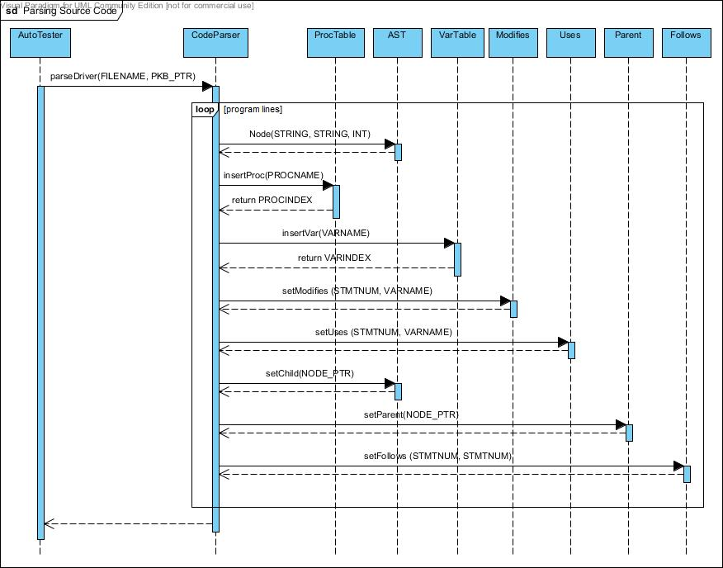

Figure 2

As shown in the above figure, Code Parser works by evaluating each line of the given source code. It creates AST Node, sets the pointers within the AST and then sets the tables and the appropriate databases in the PKB.

The above sequence diagram was also helpful while doing integration testing of the Code

Parser and the PKB. After the Code Parser extracts the design abstractions and stores

them in the PKB, we tested if the abstractions really existed in the PKB. (Refer to Section 4.3

Integration Testing)

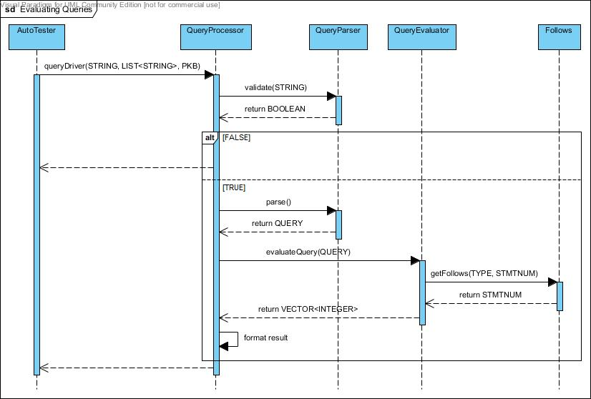

Figure 3

Figure 3 shows the sequence diagram of query evaluation process. This diagram was useful in demarcating the responsibilities of each PQL group member. For example, Query Evaluator assumes that the Query it receives is valid and syntactically correct. Therefore it is the responsibility of Query Parser to validate each query before passing it to the evaluator.

This diagram also helps to keep track of the dependencies between components. This is especially useful during debugging process of integration testing. When Query Processor fails to return the correct result, the team knows that the errors could come one of these three places, i.e. Query Parser, Query Evaluator, or PKB.

# 2. Components

## 2.1. Code Parser

Code Parser’s main functions are to read in the source code, build the AST, and set the tables (VarTable, ProcTable, TypeTable, Follows, Parent, Modifies, Uses) in PKB according to the input source code.

To build the AST, Code Parser depends on the implementation of node, which is the node structure being used to build AST. A node can have many children, therefore, we decided to use NODE_PTR_LIST for dynamic storage of the children pointers, rather than array with fixed size.

Code Parser keeps track of every relevant parent of each node being built, by storing pointers to their parents. For example when there is a while statement, a pointer to the while statement will be stored and then link all the children to their parent node.

Code Parser works by tokenizing the source code as string line by line, and then detecting the tokens for each line, and generating the types, program lines, and setting the tables accordingly.

For an assignment statement, Code Parser will convert the expression from infix to postfix, and then create the expression tree.

Code Parser does its validation by keeping track of the curly brackets (i.e. “{“ and “}” ). It keeps track of the number currently present open curly bracket, “{“. When Code Parser encounters an open curly bracket, it will push it to a stack. When it encounters a closed curly bracket, it will pop from the stack.

When Code Parser reaches the end of the source code, it will return invalid if the stack is not empty, or if Code Parser is trying to pop from an empty stack. It means there is a mismatch in the number of curly brackets.

When the stack is empty, Code Parser will accept a line which defines a procedure. If it encounters any other statement while the stack is empty, it will return invalid.

Example:

Source code (source1.txt):

procedure Mini {

A1 = 29;

a1 = 31;

i = 51; }

The following describes how the Code Parser parses the above SIMPLE program:

1. Code Parser starts reading the source code at line 1, it will check whether the stack is empty. If the stack is empty, it will be expecting a procedure declaration.
2. It then parses procedure Mini, creates an ASTNode, sets it as root, and pushes the curly bracket “{“ into the stack. Insert “Mini” into the ProcTable.
3. At line 2, Code Parser tokenizes and checks the type of statement. Since it starts with a variable, it detects the statement as an assignment statement.
4. Code Parser will check if there exists a semicolon at the end of the line because it is compulsory to have a semi colon at the end of an assignment statement. If it exists, it will create a node containing “=”, and link “A1” as the first child. The expression on the right hand side will be converted into a postfix expression, and then build the expression tree.
5. Code Parser will link the root of the expression tree as the second child of “=”, and then link the “=” to its parent, which in this case, is “procedure Mini”.
6. Code Parser will also set the VarTable, Modifies, Uses, Follows, and Parent accordingly, in this case, it will set Modifies (line 1, and variable A1), and insert A1 into the VarTable.
7. At line 3, it detects that it is an assignment statement, and repeat step 4 to 6.
8. At line 4, it detects that it is an assignment statement, and repeat step 4 to 6. In addition, Code Parser detects a closed curly bracket, Therefore, Code Parser will pop the stack.
9. End of source code is reached. It will now check whether the stack is empty.
10. Since the stack is empty, and there is no violation of the rules stated earlier. Code Parser has built the AST successfully and stored the design abstractions in the relevant tables.

## 2.2. PKB

PKB is implemented using the singleton pattern. One instance of PKB will be initialised during the construction phase of the UI (which is AutoTester). Afterwards, we will only pass the PKB pointer to other components which need to alter the PKB or call the PKB’s methods. This is to ensure that other components are always editing or accessing the same PKB object. Using the same rationale, all the sub-components of PKB (VarTable, ProcTable, ConstTable, Follows, Parent, Modifies and Uses) are singleton classes and only their pointers are passed around.

To make things clearer, some new definitions we used are as follows:

* Typedef int
  + **STMTNUM**: for statement number
  + **VARINDEX**: for variable index
  + **CONSTVALUE**: for constant value
* Typedef string
  + **VARNAME**: for variable name
  + **PROCNAME**: for procedure name
* Typedef Enum SynType {ASSIGN, IF, WHILE, STMT, BOOLEAN, CALL, VARIABLE, CONSTANT, PROGLINE, INVALID} **TYPE**
  + to discern the type of each statement number

The data structures used in the PKB for the tables and the relationships are mainly vectors as listed down below

|  |  |
| --- | --- |
| **PKB – Design Abstractions** | |
| **Tables** | **Data Structures** |
| VarTable | vector<VARNAME> |
| ProcTable | vector<PROCNAME> |
| ConstTable | vector<CONSTVALUE> |
| TypeTable | vector<TYPE> |
| **Relationships** | **Data Structures** |
| Follows | vector <STMTNUM,STMTNUM> |
| Parent | vector <STMTNUM,vector<STMTNUM>> & vector <STMTNUM,STMTNUM> |
| Uses | vector <STMTNUM,vector<VARINDEX>> |
| Modifies | vector <STMTNUM,vector<VARINDEX>> |

We are using vectors in most cases because it seemed to be the most appropriate. In most cases, we have to store the statement number (which can be translated to index of the vector) and another data type such as statement number or variable index (which will be the type of the vector).

|  |  |  |
| --- | --- | --- |
|  | Vector of size N | Map of size N |
| Insert | O(1) or O(N) if need resizing | O(log N) |
| Search | O(1) | O(log N) |

Eventually, we chose vector because we wanted to prioritize the searching speed which is much faster at O(1). We prioritize searching speed because we deem that there will be more searching than inserting. Inserting will only be done during Parser. Meanwhile searching is done on Parser and QueryProcessor. In addition, we are expecting the user of this program to have more queries (parsing is only done 1 time and there can be unlimited number of queries). As a result, we chose vector.

The PKB mainly interacts with the Code Parser and the Query Evaluator.

**Interaction with Code Parser**

After PKB is initialised, we will pass the PKB pointer to Code Parser to fill in the tables and relationships into the PKB.

For example, when the Code Parser calls insertVar(“x”), the following is done:

1. Check whether the given variable, “x”, exists in the table by iterating through the element in the table one by one
2. If yes, we will simply just return the index.
3. Otherwise, insert the element at the back of the table and return the index (table size - 1) of the variable.

For example, when the Code Parser calls setUses(12,”x”)the following is done:

1. Get the variable index of “x” from VarTable.
2. If the variable index is -1, it means that there is no such variable and thus the method will terminate.
3. If the variable index is more than -1, it means that the variable exists, therefore insert into the uses table at key 12, the value of variable index “x”.

**Interaction with Query Evaluator**

After interacting with Code Parser, PKB pointer will then be passed to Query Processor so that Query Evaluator can call the public API provided by PKB. Query Processor will need to get the tables or relationships that it needs first and only then it can call the corresponding API that it needs.

For example, if we want to call getChildren(WHILE, CALL), Query Processor needs to get parent from PKB and then calls parent->getChildren(WHILE, CALL). When it is called, it will result a list of STMTNUM x such that for each x, Parent(CALL, x) holds and x is a WHILE statement. If there exists no such statement x, an error code is returned. The steps are as follows:

1. Get parent pointer from PKB using getParent()
2. Calls the method getChildren(WHILE,CALL) from parent
3. Iterate the children table inside parent from beginning to end. The index of the vector, i, will indicate the statement number of the children.
4. Get j, the value of the vector at the specified index which is the statement number of the parent
5. If j is -1, continue with the next index from step 1.
6. Use isType(WHILE, j) to check the type of j from the TypeTable to see whether it is of type WHILE or not.
7. If not, continue with the next index from step 1.
8. If yes, ise isType(CALL, i) to check the type of I from the TypeTable to see whether it is of type CALL or not.
9. If not, continue with the next index from step 1.
10. If yes, push i into the vector of answer and continue with the next index from step 1.
11. After iterating through the whole children map, return the vector of answer.
12. If the vector of answer is empty, return the vector with -1 as the only element.

## 2.3. Query Processor

Query Processor consists of three sub-components: Query Processor (controller), Query Parser, and Query Evaluator.

### 2.3.1. Query Processor

Query Processor is a façade class for the whole component. The following shows the steps it takes:

1. Query Processor calls QueryParser to create a Query object from the given query string.
2. Query Processor then passes the Query object to the QueryEvaluator.
3. Query Evaluator will compute all necessary relations and return the results in the form of a list of integers.
4. Query Processor transforms the result into the correct display format and returns the answer to the user.

### 2.3.2. Query Parser

Query Parser has two major functionalities: query validation and query parsing, and they are implemented as functions in the QueryParser class. The controller calls query validator to check if the given query is syntactically correct. If it is, the controller will then parse the query by calling the query parser.

**Query Validation**

Query validation is done using predictive parsing method using the grammar rules written in the handbook. For example, consider this valid query:

assign a; while w; Select a such that Follows(w, a) pattern a (“x”, _”x+y”_)

Query validator will first break down the query into statements, separated by a semicolon. The query above will be broken down into three statements:

1. assign a
2. while w
3. Select a such that Follows(w, a) pattern a (“x”, _”x+y”_)

The validator will then put these statements into a static vector in the QueryParser class. The validator will iterate through the vector and check the validity of each statement separately, whether it is a declaration statement or a select statement.

Valid declaration statements will be converted into a map with the synonym as the key and its type as the value. This map is called the synonym map and will be used later by the parsing function. In this example, the synonym-map will look as follows:

|  |  |
| --- | --- |
| Synonym | Type |
| A | ASSIGN |
| W | WHILE |
| BOOLEAN | BOOLEAN |

Table

This map enables easy look up when the Query Evaluator evaluates the query. Note that the BOOLEAN type always exists in the synonym table because user can use “BOOLEAN” in his select statement without any declaration.

Select statement will be broken down into such-that and/or pattern clauses, whose parameters will be checked against the grammar rule.

Consider statement number 3 from the example above. Query validator will break the statement into three parts:

1. Select a
2. such that Follows(w, a)
3. pattern a (“x”, _”x+y”_)

The such-that clause from part number 2, will be further broken down into tokens, while validating whether each token matches the expected value from the grammar rule:

|  |  |  |  |  |  |  |  |
| --- | --- | --- | --- | --- | --- | --- | --- |
| tokens[] | | | | | | | |
| such | that | Follows | ( | w | , | a | ) |

Table

Similarly, the pattern clause from part number 3 will be processed into these tokens:

|  |  |  |  |  |  |  |
| --- | --- | --- | --- | --- | --- | --- |
| tokens[] | | | | | | |
| pattern | a | ( | “x” | , | _”x+y”_ | ) |

Table

If any of the token does not match the expected value, the validator will instantly terminate and declare the query as invalid. In the case where all the clauses are valid, all the tokens from all the statements will be put one after another into one static vector, *selectStatement*. This vector is the one that will be accessed by the parsing function later on. For efficiency, the *selectStatement* vector will only contain relevant tokens from the statement. Therefore, the unnecessary syntactic punctuation will be removed.

From the example above, the value of *selectStatement* will be:

|  |  |  |  |  |  |  |  |  |  |
| --- | --- | --- | --- | --- | --- | --- | --- | --- | --- |
| selectStatement[] | | | | | | | | | |
| Select | a | such | that | Follows | w | a | pattern | x | _”x+y”_ |

Table

**Query Parsing**

The parser processes the *selectStatement* vector from the earlier. The *selectStatement* vector will be processed to construct a Query object with the following structure.

|  |
| --- |
| Query |
| *string* selected-synonym  *string* pattern-synonym  vector<Relationship> **relationships**  *map* synonym-map |

Table

The selected synonym, in this example is ‘a’, will be stored inside a string in the Query object. The synonym map that was created earlier will also be included in the Query object. Both the such-that and pattern clauses will be stored as another object, Relationship, as the following.

|  |
| --- |
| Relationship |
| *enum* relationship-type  *string* argument-1  *string* argument-2 |

Table

Since each query can contain many select clauses, these clauses are stored inside a vector for scalability purposes. From the example above, the select-statement vector will be processed to produce the following.

|  |  |
| --- | --- |
| Query | |
| selected-synonym | a |
| pattern-synonym | a |
| relationships | [rel1, rel2] |
| synonym-table | map1 |

Table

|  |  |
| --- | --- |
| rel1 | |
| relationship-type | FOLLOWS |
| argument-1 | w |
| argument-2 | a |

Table

|  |  |
| --- | --- |
| rel2 | |
| relationship-type | PATTERN |
| argument-1 | “x” |
| argument-2 | _”x+y”_ |

Table

|  |  |
| --- | --- |
| map1 | |
| Synonym | Type |
| A | ASSIGN |
| W | WHILE |
| BOOLEAN | BOOLEAN |

Table

When the controller calls the parsing function, the function will return a query object. This object will then be passed to query evaluator.

### 2.3.3. Query Evaluator

The Query Evaluator, as the name suggests, evaluates the query given by the user. The Query Evaluator interacts with the Query Processor and the PKB.

**Interaction with Query Processor**

After the input query is validated by the Query Parser, Query Processor will pass the query object to the Query Evaluator via one of the following public methods in the Query Evaluator:

1. vector<int> evaluateQuery(Query)
2. bool evaluateQueryBoolean(Query)

Query Processor decides on the function to call by accessing the selected synonym in the Query Object. If the selected synonym is of the Boolean type (e.g Select Boolean such that Follows(1,2)), function 2 will be called. Otherwise, function 1 will be called.

The internal workings of the two functions are similar, and are separated into the following relationship types: FOLLOWS, PARENT, FOLLOWSSTAR, PARENTSTAR, MODIFIES and USES. The PKB functions to get the correct answers are then called respectively. Function 2 returns either true or false to the Query Processor. On the other hand, function 1 either returns a vector of statement numbers or a vector of variable indexes, depending on the selected synonym that the user asked for.

**Interaction with PKB**

The query evaluator has private functions for all 6 relationship types mentioned above. To portray a clearer picture of the interaction, let us assume that the query is as follows:

assign a; Select a such that follows(4, a)

As the selected synonym is not Boolean, function 1 is invoked. The respective private method that will be called is evaluateFollows(Relationship r, queryMap m, string selectedSyn). The private function will be responsible for the interaction with the PKB follows table and the correct invoking of the relevant PKB methods. This is done by analysing the relationship tokens and the selected synonym. In the above case, as selected synonym is equals to the first token, the PKB method getFollows(type t, int stmtnum) will be summoned. The parameter t will indicate to the method to only return assign statements.

Likewise, other relationships such as PARENT, MODIFIES and USES work in a similar way with their corresponding private methods such as evaluateParent and evaluateModifies. Queries with BOOLEAN as the selected synonym will be accessed by functions such as evaluateFollowsBoolean and evaluateParentBoolean which call their respective PKB methods. The only discrepancy is FOLLOWSSTAR and PARENTSTAR which use the existing FOLLOWS and PARENT PKB methods to compute the result; there are no extra APIs made to cater to the computation of these two relationships. The decision to relay the responsibility of these two relationships to the Query Evaluator was made on the basis of separation of concerns.

**Pattern**

To evaluate Patterns, we do DFS(Depth First Search) starting from the ASTRoot. The DFS itself is implemented using a Stack and continues until the Stack is empty. While running the DFS, whenever a Node with the assign type is popped, we evaluate both the leftHandSide(which is represented as the first child of the assign Node) and the rightHandSide(which is represented as the second child of the assign Node). If after evaluation both leftHandSide and rightHandSide are deemed to contain the subtree specified in the arguments, we append the progLine of the assign Node to the vector<int> we return to the QueryProcessor.

# Development Plan

The following tables show our implementation and testing schedule for the 3 mini-iterations.

|  |  |  |  |  |  |
| --- | --- | --- | --- | --- | --- |
| Team Member | | **Mini-Iteration 1** | | | |
| Implement CodeParser to parse SIMPLE program with simple assignment statements. Unit Testing. | Create AST while parsing SIMPLE program. | Implement VarTable, Follows in PKB. Unit Testing. | Implement TypeTable, Parent in PKB. Set up PKB as singleton. Unit Testing. |
| PKB | Kester | ✓ | ✓ |  |  |
| Yohanes |  |  |  | ✓ |
| Ipsita |  |  | ✓ |  |
| PQL | Lacie |  |  |  |  |
| Hisyam |  |  |  |  |
| Adinda |  |  |  |  |

|  |  |  |  |  |  |
| --- | --- | --- | --- | --- | --- |
| Team Member | | **Mini-Iteration 1** | | | |
| Implement Query Evaluator for Follows, Parent. Unit Testing. | Make Query and Relationship objects. Implement query parser for such-that clause. Unit Testing. | Implement Query Processor to integrate Query Parser and Query Evaluator. | Write system test cases for Mini-Iteration 1. |
| PKB | Kester |  |  |  |  |
| Yohanes |  |  |  |  |
| Ipsita |  |  |  | ✓ |
| PQL | Lacie | ✓ |  |  |  |
| Hisyam |  |  | ✓ |  |
| Adinda |  | ✓ |  |  |

|  |  |  |  |  |  |
| --- | --- | --- | --- | --- | --- |
| Team Member | | **Mini-Iteration 2** | | | |
| Implement complete CodeParser. Integrate with VarTable, TypeTable, Follows, Parent relationships. | Write system test cases for Mini-Iteration 1 and 2. | Fix PKB errors for previous iteration. | Implement Query Evaluator for Follows Star, Parent Star. Unit Testing. |
| PKB | Kester | ✓ |  |  |  |
| Yohanes |  |  | ✓ |  |
| Ipsita |  | ✓ |  |  |
| PQL | Lacie |  |  |  | ✓ |
| Hisyam |  |  |  |  |
| Adinda |  |  |  |  |

|  |  |  |  |  |  |
| --- | --- | --- | --- | --- | --- |
| Team Member | | **Mini-Iteration 2** | | | |
| Integration Testing of CodeParser with PKB. | Integration Testing of CodeParser and PKB. | Integrate with AutoTester. Start System testing. | Validate query for such-that clause.  Implement Query Parser for pattern clause. Unit Testing. |
| PKB | Kester | ✓ |  |  |  |
| Yohanes |  |  |  |  |
| Ipsita |  |  | ✓ |  |
| PQL | Lacie |  | ✓ |  |  |
| Hisyam |  |  | ✓ |  |
| Adinda |  |  |  | ✓ |

|  |  |  |  |  |
| --- | --- | --- | --- | --- |
| Team Member | | **Mini-Iteration 3** | | |
| Implement Modifies in PKB. Unit Testing. | Implement Uses in PKB. Unit Testing. | Write test cases for system testing of Mini-Iteration 3. Do system testing for Modifies, Uses and pattern and a mixture. |
| PKB | Kester |  |  |  |
| Yohanes |  | ✓ | ✓ |
| Ipsita | ✓ |  | ✓ |
| PQL | Lacie |  |  |  |
| Hisyam |  |  | ✓ |
| Adinda |  |  |  |

|  |  |  |  |  |
| --- | --- | --- | --- | --- |
| Team Member | | **Mini-Iteration 3** | | |
| Implement Query Evaluator for Modifies and Uses. Unit Testing. | Implement Query Evaluator for pattern. Unit Testing. | Implement complete Query Parser for complex queries. Unit Testing. |
| PKB | Kester |  |  |  |
| Yohanes |  |  |  |
| Ipsita |  |  |  |
| PQL | Lacie | ✓ |  |  |
| Hisyam |  | ✓ |  |
| Adinda |  |  | ✓ |

# 4. Testing

## 4.1. Testing Plan

Figure 4

We did testing on 3 different levels, namely unit testing (using CPPUnit), integration testing (using CPPUnit) and system testing (using AutoTester). Unit Testing was done while we were implementing individual components. Integration testing was done between SIMPLE program parser and PKB and between PKB and Query component.

From the testing experience in this project, we realised the need for timely and consistent unit, integration and system testing. By testing individual components early, we detect bugs earlier in the project’s lifetime, thus, saving us time towards the end of the project. We also did regression testing by reusing our unit tests and system tests. This helped us to quickly identify bugs that could have been introduced while we were trying to solve other bugs.

## 4.2. Unit Testing

Unit Testing was done on every sub-component of the SPA.

For the Front-End, some examples would be the TestNode.cpp, which is used to unit test our ASTNode object, and the TestParser.cpp, which is used to unit test all source code parsing methods.

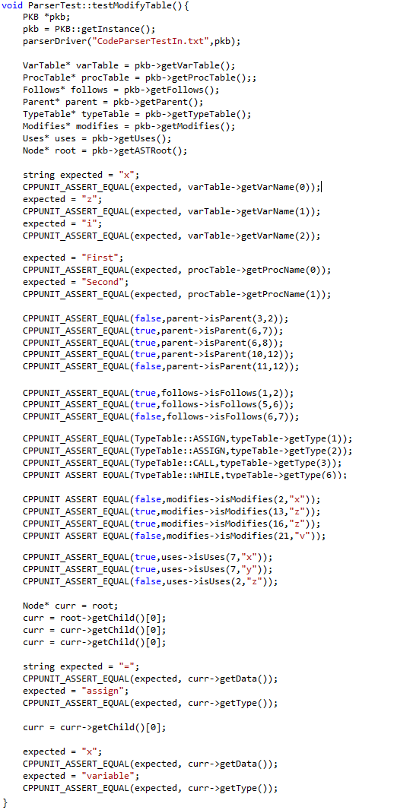

For the Query Processor, we have the QueryEvaluatorTest.cpp, which is used to unit test all evaluation after Query Pre-Processing, and the QueryParserTest.cpp, which is used to unit test methods involved in parsing the queries into QueryTree objects.

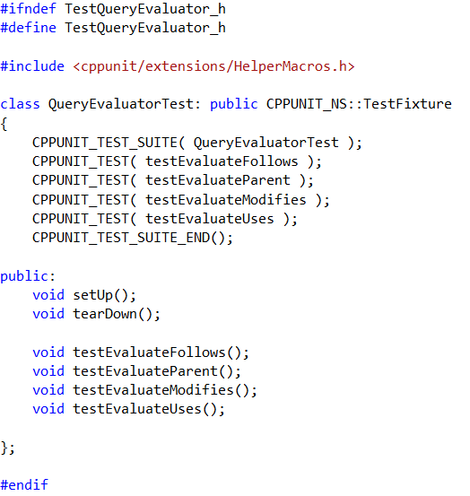

For the PKB, every single implemented relationship(Parent, Follows, Uses, and Modifies) has a UnitTest specific to the relationship.

## 

## 4.3. Integration Testing

Integration Testing was split into two parts, Parser-PKB and PKB-Query Processor.

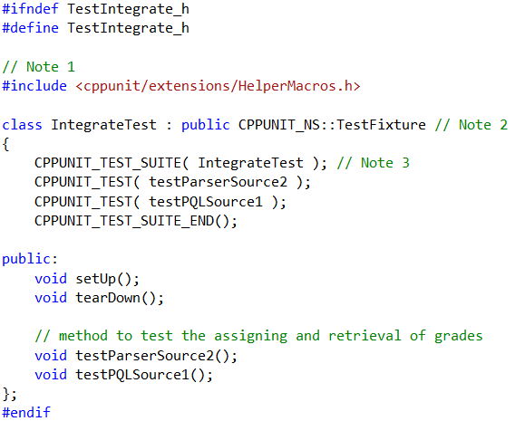

For Parser-PKB testing, a sample source is parsed and assertions are made to see the correctness of said parsing.

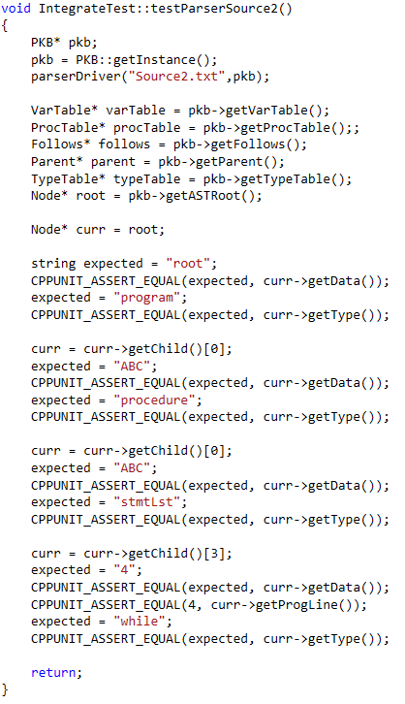

For PKB-Query Processor testing, queries are parsed by the QueryParser and then evaluated in the QueryProcessor. The answers provided by the QueryProcessor are asserted to check for correctness.

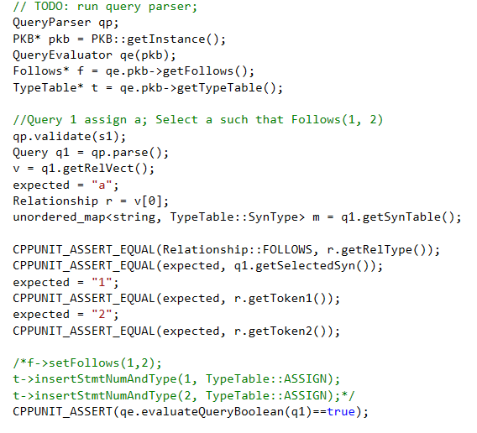

## 4.4. System Testing

All system testing was executed by running test cases using the AutoTester. There are five source codes for parsing, and a total of 9 query sets. Each source code is associated to a certain mini iteration, and each query set is associated to a different part of the iteration.

Sample Source:

procedure Mini {

A1 = 29;

a1 = 31;

i = 51; }

procedure mini {

i = a1;

a1 = A1; }

procedure q {

q = A1;

A1 = 90; }

Sample Query for source 1:

5

cat: Iteration 1 requirements

1 - Follows, Typed, ImplStmtLine :: Which statement is followed by statement in line 7

assign a;

Select a such that Follows(a, 7)

6

5000

2 - Follows, Typed, ImplStmtLine :: Which assign statement follows statement in line 3

assign a;

Select a such that Follows(3, a)

none

5000

3 - Follows, Typed, ImplStmtLine :: Which statement follows statement in line 4

stmt s;

Select s such that Follows(4, s)

5

5000

4 - Follows, Boolean :: Is Follows(6, 7) true

Select BOOLEAN such that Follows(6, 7)

true

5000

5 - Follows, Boolean :: Is Follows(5, 6) true

Select BOOLEAN such that Follows(5, 6)

false

5000

# 5. Coding Standards

Our team members adopted similar coding standards which are adjusted appropriately and respectively according to the design specifications of various components. Some of the coding standards that the components possess are listed below:

1. Indentation and whitespace
   1. Indication of code segments
2. Comments to enhance understanding and communication
3. Descriptive variable declarations
   1. Always start with lower case
   2. Use CamelCase
   3. Use only letters and numbers
4. Informative function naming conventions
   1. All getters start with “get”
   2. All setters start with “set”
   3. All functions that start with “is” returns a Boolean value
5. Keep it simple and effective
   1. Avoid complex code fragments with
6. Refactoring

**Standards between abstract APIs and concrete APIs**

The correspondence between the abstract and concrete APIs was enhanced by doing the following:

1. The abstract APIs provides the interface for the concrete APIs
2. Making abstract APIs as comprehensive as possible
   1. Offering an Extensive description of the abstract APIs
   2. Specifying the complete parameters needed for the function

# 6. API

## 6.1. Parser

|  |
| --- |
| **Parser**  *Overview*: Parser is responsible to read the source code, creates AST, and set the tables accordingly. |
| **API:** |
| VOID parseDriver(FILENAME fileName, PKB_PTR pkb);  Parameter:   * fileName – filename of the source code. (e.g. “source1.txt”) * pkb – is a pointer to a pkb class, which contains all the tables and data needed to answer queries.   (e.g. VARTABLE,PROCTABLE,FOLLOWS,MODIFIES,PARENT,USES,AST, etc)  Description: parser reads in the source code, tokenizes and detects the structure of the code, then create AST, and set the tables accordingly. |

## 6.2. Node (AST)

|  |
| --- |
| **Node**  *Overview*: Node is the node structure of AST nodes. |
| **API (Constructor):** |
| Node();  Description: a constructor to create a blank node. |
| Node(DATA newData, TYPE newType);  Description: a constructor to create a node with newData and newType as its attributes. |
| Node(DATA newData, TYPE newType, STMTNUM progLine);  Description: a constructor to create a node with newData, newType, and progLine as its attributes. |
| API (Method): |
| NODE_PTR getChild(INDEX i);  Description: returns a pointer to a node which is the i th children of the current node. First children is index 0. |
| NODE_PTR_LIST getChild();  Description: returns a LIST of Node pointers of the current node’s children. |
| NODE_PTR getParent ();  Description: returns a pointer to a node which is the parent of the current node. |
| TYPE getType ();  Description: returns the statement type of the current node. |
| DATA getData ();  Description: returns the Data of the current node. |
| STMTNUM getProgLine();  Description: returns the program line of the current node. |
| VOID setChild(NODE_PTR newChild);  Description: set the next children of the current node to be the node pointed by newChild. |
| VOID setData(DATA newData);  Description: set the DATA of the current node to be newData. |
| VOID setType(TYPE newType);  Description: set the TYPE of the current node to be newType. |
| VOID setParent(NODE_PTR newParent);  Description: set the next parent of the current node to be the node pointed by newParent. |
| VOID setProgLine(STMTNUM newProgLine);  Description: set the STMTNUM progLine of the current node to be newProgLine. |
| VOID printPreOrderExpressionTree(NODE_PTR root);  Description: print the details of every node from root, using pre-order traversal. |
| **VOID stringPreOrderExpressionTree(NODE_PTR root,** STRING_REF word);  Description: retrieve the details of every node from root, using pre-order traversal, and store it in word, which is a STRING passed by reference. |

## 6.3. Vartable

|  |
| --- |
| **VarTable**  *Overview*: VarTable stores all the variables from a source program. |
| **API:** |
| VARINDEX insertVar (VARNAME varName);  Parameters:  varName - name of the variable  Description:  If varName is not in the VarTable, inserts varName into the  VarTable and returns its index. Otherwise, return its index and the table remains unchanged. |
| VARNAME getVarName (VARINDEX index);  Parameters:  index - index of the variable  Description: Returns the name of a variable at VarTable [index]  If ‘index’ is out of range, return error code |
| VARINDEX getVarIndex (VARNAME varName);  Parameters:  varName - name of the variable  Description: If varName is in VarTable, returns its index. Otherwise, returns error code |
| INTEGER getNumVar() ;  Description: Returns the total number of unique variables stored in the VarTable. |

## 6.4. Proctable

|  |
| --- |
| **ProcTable**  *Overview*: ProcTable stores all the procedure names from a source program. |
| **API:** |
| PROCINDEX insertProc (PROCNAME procName);  Parameters:  procName - name of the procedure to be inserted into ProcTable  Description: If procName is not in the ProcTable, inserts procName into the  ProcTable and returns its index. if procName already exists, return its index and the table remains unchanged. |
| PROCINDEX getProcIndex (PROCNAME procName);  Parameters:  procName - procedure name  Description: If procName has a corresponding index in the ProcTable, returns its index. Otherwise, returns error code. |
| PROCNAME getProcName (PROCINDEX index);  Parameters:  index - index of the procedure  Description: If the procedure denoted by the index ‘index’ exists in the ProcTable, returns the name of a procedure at ProcTable.  If ‘index’ is out of range, return error code |
| INTEGER getNumProcedures () ;  Description: Returns the total number of unique procedures stored in the procTable. |

## 6.5. TypeTable

|  |
| --- |
| **TypeTable**  *Overview*: TypeTable stores all the types (assign,calls, while,etc) for each program line, from a source program. |
| **API:** |
| TYPEINDEX insertStmtNumAndType (STMTNUM s, TYPE t);  Description: Associate statement s, with type t, store it in the typeTable, and returns its index. If the pair already exists, return its index and the table remains unchanged |
| TYPE getType (STMTNUM s);  Description: Search statement s in the typeTable and returns the type of statement s. if s is out of range or invalid, return error code. |
| STMTNUM_LIST getAllStmts (TYPE t);  Description: retrieve all statements of type t, store that in a LIST, and return the LIST. |
| BOOLEAN isType (TYPE t, STMTNUM s);  Description: If STMTNUM s, is associated with TYPE t, in the typeTable, returns true. If s is invalid of out of range, returns false. |

## 6.6. Follows and Follows*

|  |
| --- |
| **Follows**  *Overview*: Follows is used to keep track of the Follows relationship between two statements (denoted by their statement numbers: STMT#). |
| **API:** |
| VOID setFollows (STMTNUM s1, STMTNUM s2);  Description: Set the Follows(s1, s2) in the FollowsTable.  If s1 or s2 are out of range, do nothing. |
| BOOLEAN isFollows (STMTNUM s1, STMTNUM s2);  Description: If the Follows(s1, s2) is true, return true. Otherwise, return false.  If s1 or s2 are out of range, return false; |
| BOOLEAN isFollows (TYPE t1, TYPE t2);  Description: If Follows(t1, t2) is true, return true, where t1 is the type of statement 1, and t2 is the type of statement 2. Otherwise, return false.  If t1 or t2 is of invalid type, return false; |
| BOOLEAN isFollowedBy (TYPE t, STMTNUM s2);  Description: If getFollowedBy (t,s) returns a valid result, this method returns true.  If s2 is out of range or type t is invalid, return false; |
| STMTNUM getFollows (TYPE t, STMTNUM s);  Description: Returns x such that Follows(s, x) holds. (and if x is of TYPE t)  If s does not exist or is out of range, return error code. |
| STMTNUM getFollowedBy (TYPE t, STMTNUM s);  Description: Returns x such that Follows(x, s) holds. (and if x is of TYPE t)  If s does not exist or is out of range, return error code. |
| STMTNUM_LIST getFollows (TYPE t1, TYPE t2);  Description: Returns all STMTNUM x such that for every x, Follows(t1, x) holds, and every x is of type t2.  If s does not exist or is out of range, return error code. |
| STMTNUM_LIST getFollowedBy (TYPE t1, TYPE t2);  Description: Returns all STMTNUM x such that for every x, Follows(x, t2) holds, and every x is of type t1.  If s does not exist or is out of range, return error code. |
| BOOLEAN isFollowsStar (STMTNUM s1, STMTNUM s2);  Description: If Follows*(s1, s2) is true, returns true. Else, returns false.  If s1 or s2 are out of range, return error code |
| STMTNUM_LIST getFollowsStar (STMTNUM s);  Description: Returns a list containing statements x such that Follows*(s, x) holds.  If s is out of range r does not exist, return error code |
| STMTNUM_LIST getFollowedStarBy (STMTNUM s);  Description: Returns a list containing statements x such that Follows*(x, s) holds.  If s is out of range r does not exist, return error code |

## 6.7. Parent and Parent*

|  |
| --- |
| **Parent**  *Overview*: Parent is used to keep track of the Parent relationship between two statements.  ParentStar methods are currently being evaluated by QueryEvaluator, but we are planning to move the methods here, (Parent). |
| **API:** |
| VOID setParent (STMTNUM s1, STMTNUM s2);  Description: Set the Parent(s1, s2) in the ParentTable.  If s1 or s2 are out of range, do nothing. |
| BOOLEAN isParent (STMTNUM s1, STMTNUM s2);  Description: If Parent(s1, s2) holds, return true. Else, return false.  If s1 or s2 are out of range, return false. |
| BOOLEAN isParent (TYPE t1, TYPE t2);  Description: If Parent(t1, t2) holds, return true. Else, return false.  If t1 or t2 is invalid, return false. |
| BOOLEAN isParent (TYPE t1, STMTNUM s2);  Description: If Parent(s2, t1) holds, return true (where t1 is the type of the statement). Else, return false.  If t1 is invalid or s2 is out of range, return false. |
| BOOLEAN isChildren (TYPE t1, STMTNUM s2);  Description: If Parent(t1, s2) holds, return true (where t1 is the type of the statement). Else, return false.  If t1 is invalid or s2 is out of range, return false. |
| STMTNUM_LIST getParent (TYPE t1, TYPE t2, STMTNUM s);  Description:  Returns ALL STMTNUM x such that for each x, Parent(x, s) holds.  Where s is of type t2, and each x is of type t1.  If no such statement x exists or if s is out of range, return error code. |
| STMTNUM_LIST getChildren (TYPE t1, TYPE t2, STMTNUM s);  Description:  Returns ALL STMTNUM x such that for each x, Parent(s, x) holds.  Where s is of type t2, and each x is of type t1.  If no such statement x exists or if s is out of range, return error code. |
| STMTNUM_LIST getParent (TYPE t1, TYPE t2);  Description:  Returns ALL STMTNUM x such that for each x, Parent(x,t2) holds.  where each x is of type t1.  If no such statement x exists or if s is out of range, return error code. |
| STMTNUM_LIST getChildren (TYPE t1, TYPE t2);  Description:  Returns ALL STMTNUM x such that for each x, Parent(t2,x) holds.  where each x is of type t1.  If no such statement x exists or if s is out of range, return error code. |
| STMTNUM getParent (TYPE t1, STMTNUM s2);  Description:  Returns STMTNUM x such that Parent(x, t2) holds.  where each x is of type t1.  If no such statement x exists or if s is out of range, return error code. |
| STMTNUM_LIST getChildren (STMTNUM s);  Description:  Returns ALL STMTNUM x such that Parent(s, x) holds.  If no such statement x exists or if s is out of range, return error code. |
| BOOLEAN isParentStar (STMTNUM s1, STMTNUM s2);  Description: If Parent*(s1, s2) is holds, return true. Else, return false.  If s1 or s2 are out of range, return false. |
| STMTNUM_LIST getChildrenStar (STMTNUM s);  Description: Returns a list containing ALL STMTNUM x such that Parent*(s, x) holds.  If no such statement x exists or if s is out of range, return error code |
| STMTNUM_LIST getParentStar (STMTNUM s);  Description: Returns a list containing ALL STMTNUM x such that Parent*(x, s) holds.  If no such statement x exists or if s is out of range, return error code |

## 6.8. Modifies

|  |
| --- |
| **Modifies**  *Overview*: Modifies is used to keep track of the Modifies relationship. |
| **API:** |
| VOID setModifies (STMTNUM s, VARNAME varName);  Description: Set the Modifies relationship between s and varName to be true in the modifiesAssignmentTable.  If either v or s given is out of range, do nothing. |
| VOID setModifiesProcedures (PROCNAME procName, VARNAME varName);  Description: Set the Modifies relationship between procName and varName to be true.  If either p or v given is out of range, do nothing. |
| BOOLEAN isModifies (STMTNUM s, VARNAME varName);  Description: If the Modifies relationship between s and v in the ModifiesAssignmentTable is true, return true. Otherwise, return false.  If either v or s given is out of range, return false. |
| BOOLEAN isModifiesProcedures (PROCNAME procName, VARNAME varName)  Description: If the Modifies relationship between procName and varName in the ModifiesStatementsTable is true, return true. Otherwise, return false.  If either s or vgiven is out of range, return false. |
| STMTNUM_LIST getModifies (TYPE t);  Description: Return the list of all STMTNUM x, of type t, that modifies any variables.  If there is no such statements, return empty LIST. |
| VARINDEX_LIST getModifies (STMTNUM s);  Description: returns all VARINDEX x such that Modifies(s,x) is true.  If s is out of range, or there no such VARINDEX, return empty LIST. |
| STMTNUM_LIST getModifies (TYPE t, VARNAME varName);  Description: Return the list of all STMTNUM x, of type t, such that Modifies(x,varName) is true.  If there is no such statements, return empty LIST. |
| PROCNAME_LIST getModifiesProcedures(VARNAME varName);  Description: Given varName, get all of the Procedure whose Modifies relationship with varName in the ModifiesStatementsTable is true. Return the list of all of the PROCNAME.  If no PROCNAME fulfils the condition, return empty LIST. |
| VARNAME_LIST getModifiesProcedureVariable(PROCNAME procName);  Description: Given procName, get all of the VARNAME whose Modifies relationship with procName in the ModifiesStatementsTable is true. Return the list of all of the VARNAME.  If no VARNAME fulfils the condition, return empty LIST. |

## 6.9. Uses

|  |
| --- |
| **Uses**  *Overview*: Uses is used to keep track of the Uses relationship |
| **API:** |
| VOID setUses (STMTNUM s, VARNAME varName);  Description: Set the Uses relationship between s and varName to be true.  If s or v given is out of range, do nothing. |
| VOID setUsesProcedures (PROCNAME procName, VARNAME varName);  Description: Set the Uses relationship between procName and varName to be true.  If either procName or varName given is invalid, do nothing. |
| BOOLEAN isUses (STMTNUM s, VARNAME varName);  Description: If the Uses relationship between s and varName in the UsesStatementsTable is true, return true. Otherwise, return false.  If either s or varName is invalid, return false. |
| BOOLEAN isUsesProcedures (PROCNAME procName, VARNAME varName);  Description: If the Uses relationship between procName and varName in the UsesStatementsTable is true, return true. Otherwise, return false.  If either procName or varName is invalid, return false. |
| VARINDEX_LIST getUses (STMTNUM s);  Description: obtain all VARNAME x such that Uses(s,x) is true for each x. Return the list of all of the VARINDEX, by converting it using varTable.  If s is out of range, return empty LIST. |
| STMTNUM_LIST getUses (VARNAME varName);  Description: return all STMTNUM x, such that for each x, Uses(x,varName) is true.  If v is invalid, return empty LIST. |
| VARNAME_LIST getUsesProceduresVariable(PROCNAME procName);  Description: Get all of the VARNAME whose Uses relationship with procName in the UsesStatementsTable is true. Return the list of all of the VARNAME.  If procName is invalid, return empty LIST. |
| PROCNAME_LIST getUsesProcedures(VARNAME varName);  Description: Given varName, get all of the Procedure whose Uses relationship with v in the UsesStatementsTable is true. Return the list of all of the PROCNAME.  If varName is invalid, return empty LIST. |

## 6.10. CALLS and CALLS*

|  |
| --- |
| **Calls**  *Overview*: Calls is used to keep track of the Calls relationship between procedures. |
| **API:** |
| VOID setCalls (PROCNAME procCall, PROCNAME procCalled);  Description: Set the Calls relationship between procCall and procCalled to be true. If procCall or procCalled does not exists, error (or throw exception). |
| BOOLEAN isCalls (PROCNAME procCall, PROCNAME procCalled);  Description: If the Calls relationship between procCall and procCalled is true, return true. Otherwise, return false.  If procCall or procCalled does not exists, return false. |
| PROCNAME_LIST getCalls(PROCNAME procCalled);  Description: Returns all procedures that calls procCalled directly. |
| PROCNAME_LIST getCalled(PROCNAME procCalls);  Description: returns all procedures that are called by procCalls directly. |
| PROCNAME_LIST getCallsStar(PROCNAME procCalled);  Description: returns all procedures that calls procCalled indirectly or directly . |
| PROCNAME_LIST getCalledStarBy(PROCNAME procCalls);  Description: returns all procedures that are called by procCalls indirectly or directly. |

## 6.11. CFG (Next and Next*)

|  |
| --- |
| **CFG**  *Overview*: This API provides the necessary methods to build a control flow graph and to work with the Next relationship. |
| **API:** |
| GNODE createNode(INDEX progLine);  Parameters:  progLine - program line in the given SIMPLE program  Description: Creates and returns reference to a GNode corresponding to the progLine given. |
| GNODE setNextNode(GNODE currNode, GNODE nextNode);  Parameters:  currNode - current GNODE  nextNode - next GNODE  Description: Link nextNode as the next node of the currNode. Returns the reference of the currNode. |
| BOOLEAN isNext(INDEX progLine1, INDEX progLine2);  Description: If the Next(progLine1, progLine2) holds, return true. Else, do nothing. If progLine1 or progLine2 does not exist, returns false |
| INDEX getNext(INDEX progLine);  Description: Returns the index of the program line which comes next directly after progLine. If progLine is out of range, returns error code |
| INDEX getPrevious(INDEX progLine);  Description: Returns the index of the program line which comes before directly progLine. If progLine is out of range, returns error code |
| INDEX getNextStar(INDEX progLine);  Description: Returns the index of the program line which comes next after dircetly or indirectly progLine. If progLine is out of range, returns error code |
| INDEX getPreviousStar(INDEX progLine);    Description: Returns the index of the program line which comes before directly or indirectly progLine. If progLine is out of range, returns error code |

## 6.12. Affects

|  |
| --- |
| **Affects**  *Overview*: Affects is used to keep track of the Affects relationship between two statements. |
| **API:** |
| BOOLEAN isAffects (STMTNUM s1, STMTNUM s2);  Description: If Affects(s1, s2) holds, return true. Else, return false.  If s1 or s2 are out of range, return false |
| STMTNUM getAffects (STMTNUM s);  Description: Get a STMTNUM from the right side of the AffectsTable where the left side is STMTNUM s and the relationship is true. Return the STMTNUM.  If the STMTNUM does not exist or s is out of range, return error code. |
| STMTNUM getAffectedBy (STMTNUM s);  Description: Get a STMTNUM from the left side of the AffectsTable where the right side is STMTNUM s and the relationship is true. Return the STMTNUM.  If the STMTNUM does not exist or s is out of range, return error code. |

## 6.13. Affects*

|  |
| --- |
| **AffectsStar**  *Overview*: AffectsStar is used to keep track of the AffectsStar relationship between two STMT# |
| **API:** |
| BOOLEAN isAffectsStar (STMTNUM s1, STMTNUM s2);  Description: If Affects*(s1, s2) holds, return true. Else, return false.  If s1 or s2 are out of range, return false. |
| STMTNUM_LIST getAffectsStar (STMTNUM s);  Description: Get all of the STMTNUM from the right side of the AffectsStarTable where the left side is STMTNUM s and the relationship is true. Return all of the STMTNUM in list.  If the STMTNUM does not exist or s is out of range, return error code. |
| STMTNUM_LIST getAffectedStarBy (STMTNUM s);  Description: Get all of the STMT# from the left side of the AffectsStarTable where the right side is STMT# s and the relationship is true. Return all of the STMT# in a list.  If the STMT# does not exist or s is out of range, return error code. |

# 7. Discussion

## 7.1 What worked fine for you? What was a problem?

During the course of the module, there was a combination of things that went right and some which went wrong. Some of the things that went well were our team dynamics and coding ability. On the other hand, we had some problems in making design decision and following mini-iterations diligently.

In contrast to our previous software engineering module (CS2103), this time we got to choose our teammates. Consequently, this improved our team dynamic by leaps and bounds. This is because we already know each other’s strengths and weaknesses. As a result, work allocation was settled swiftly. In addition, we can be more tact and direct in commenting each other’s work which makes our work more efficient as well. As a unit, we worked cohesively.

In terms of coding ability for this module, we think our group is very stable. We struggled in the beginning during the transition to C++ and Visual Studio but afterwards we did not encounter significant or major difficulties in terms of implementing any part of SPA, thus far. Hopefully this continues in CS3202.

We do have problem in the design decision department. We did not really think of the possible consequences of making design decision, thus, resulting in many changes being made along the way. If we had been more systematic in our approach and thought ahead at the start, maybe, we would have prevented such problems.

Lastly, mini-iterations could not be followed strictly in certain weeks. This is due to work allocation as some of us failed to meet our own internal deadlines due to one reason or another. As a result, we had to rush quite a bit towards the end of the semester which might lower the quality of our application. However, we still tried our level best to do sufficient and thorough integration and system testing at various levels. In retrospect, we will take deadlines more seriously in the future in CS3202 so as to adhere to the schedule set by the leader and ensure that everything goes smoothly.

## 7.2 What would you do differently if you were to start the project again?

We are quite rushed nearing the end of the semester so we could have started the project earlier (or at least implemented the main bulk of our program earlier). What we can do is to take assignment 2 and 3 more seriously as they are directly related to our project. In addition, we could have adhered to the deadlines set for each iteration. This would have given us more than enough time to do thorough testing at every stage and also reduce our workload and stress level towards the end of the semester.

## 7.3 Comment on the experience gained in this project with respect to:

### A) Working as a team

The ultimate lesson that we learned was to adhere to deadlines. It is very crucial because if one person’s work is delayed, it is possible for the whole team’s progress to be dragged down especially during integration testing of one component with another. Working as a team is crucial in the success of any team project.

### B) Complexity of the SPA problem and program solution

We think it is manageable so far and the implementation of the solution is not too difficult.

### C) What you have learnt in this project course

We have learned how to code in C++ using Visual Studio. We have also learned the importance of following a common coding standard for the team to avoid any confusion. It is vital to exercise good software engineering practices as well such as writing meaningful comment when committing a code.

## 7.4 Comment on the tools used for the project

### Were the recommended tools useful?

Yes, but we could have used a newer version of visual studio. In addition, we could have used a distributed version control system like Mercurial instead.

### What other tools did you use (if any), and in what ways were they useful?

No.

### What were the problems you faced when using each tool?

We needed to familiarise ourselves with Visual Studio and CPPUNIT which took us a lot of time. Furthermore, as SVN is outdated as a revision control system, we encountered problems at times because crucial features which are available in Mercurial are not available in SVN.

### In which areas would you like to have had more tool support?

Revision control system and integration testing.

## 7.5 What management lessons have you learned?

Time management is very crucial. This includes each member’s time management both inside and outside the project. In the project, we learnt the need to strictly adhere to our own internal deadlines. As internally set deadlines may sometimes clash with external deadlines, it is crucial that we plan our time well on a personal level.

People management is also equally important. When working in a group, it is very different than working on your own. We need to be responsible and accountable for our own components. It is also crucial to remain contactable, such as, when debugging the system via system testing.

## 7.6 Suggest how this project course can be improved

We think this project could be tailored for us to learn new things that will be useful when we proceed to search for jobs and internships in the future. In terms of coding, we did not really learn anything new except learning C++. As for software engineering practices, like refactoring, we were simply encouraged to use it as and when necessary. For example, in CS2103, we got to choose a special feature which compelled us to learn new things such as Google integration or GUI implementation in Java.